Component Level Interaction

We create one component called child component in side app component and then we will try to pass data from app to child and child to app component.

Create an application: ng new complevelinteraction

Move to app: cd complevelinteraction

Open vs code from the same: code .

Run app: ng serve, check output localhost:4200

Let’s create a component called child

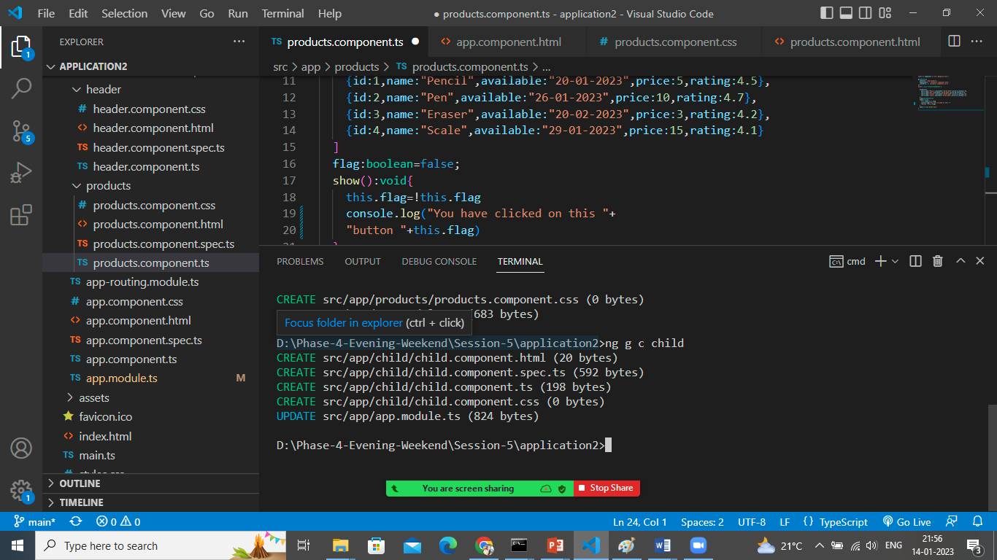

Let’s do the communication between Parent (App component) and Child (child component)

Update below mentioned code in app.component.html

<div class="container">

  <h1>App Component (Parent Component)</h1>

  Enter message: <input type="text" #ptext (keyup)="0"/>

  <!-- passing data to child component-->

  <app-child [pdata]="ptext.value"></app-child>

</div>

The data which is passed as property binding to child component to receive that required input attribute so update child.component.ts file as below

import { Component } from '@angular/core';

@Component({

  selector: 'app-child',

  templateUrl: './child.component.html',

  styleUrls: ['./child.component.css'],

  inputs:['pdata']

})

export class ChildComponent {

  pdata:string=""

}

Update child.component.html file to print the data coming from Parent

<h1>This is Child Component</h1>

<h3>Data Coming from parent component is {{pdata}}</h3>

Let’s pass the data from Child to Parent

For that we need 2 things, output + event emitter

Open child.component.html

<h1>This is Child Component</h1>

Enter Child's Message:<input type="text" #ctext (keyup)="onchange(ctext.value)"/>

<!-- when the key typed it will call the method named onchange and pass the data

which is entered in the textfield-->

<h3>Data Coming from parent component is {{pdata}}</h3>

Create that method in child.component.ts file

import { Component, EventEmitter } from '@angular/core';

@Component({

  selector: 'app-child',

  templateUrl: './child.component.html',

  styleUrls: ['./child.component.css'],

  inputs:['pdata'],

  outputs:['cevent']

})

export class ChildComponent {

  pdata:string=""

  //to emit the value entered by user I want event emitter

  cevent= new EventEmitter<string>()

  onchange(value:string){

    this.cevent.emit(value)

  }

}

Open app.component.ts and declare a variable

export class AppComponent {

  title = 'application2';

  cdata:string=""

}

To print this value edit app.component.html file

<div class="container">

  <h1>App Component (Parent Component)</h1>

  The Message came from child component {{cdata}}

  <br><br>

  Enter message: <input type="text" #ptext (keyup)="0"/>

  <!-- passing data to child component-->

  <app-child [pdata]="ptext.value" (cevent)="cdata=$event"></app-child>

</div>

In app-child tag when the cevent trigger any event it will return the data through event and that is stored in variable cdata which simply we can print using interpolation.